Whole Practice Appraisal Guidance

Contents

Page 3 Flowchart.

Page 4 Guidance Notes.

Page 8 Appendix 1: WP1 Letter.

Page 10 Appendix 2: Frequently Asked Questions.

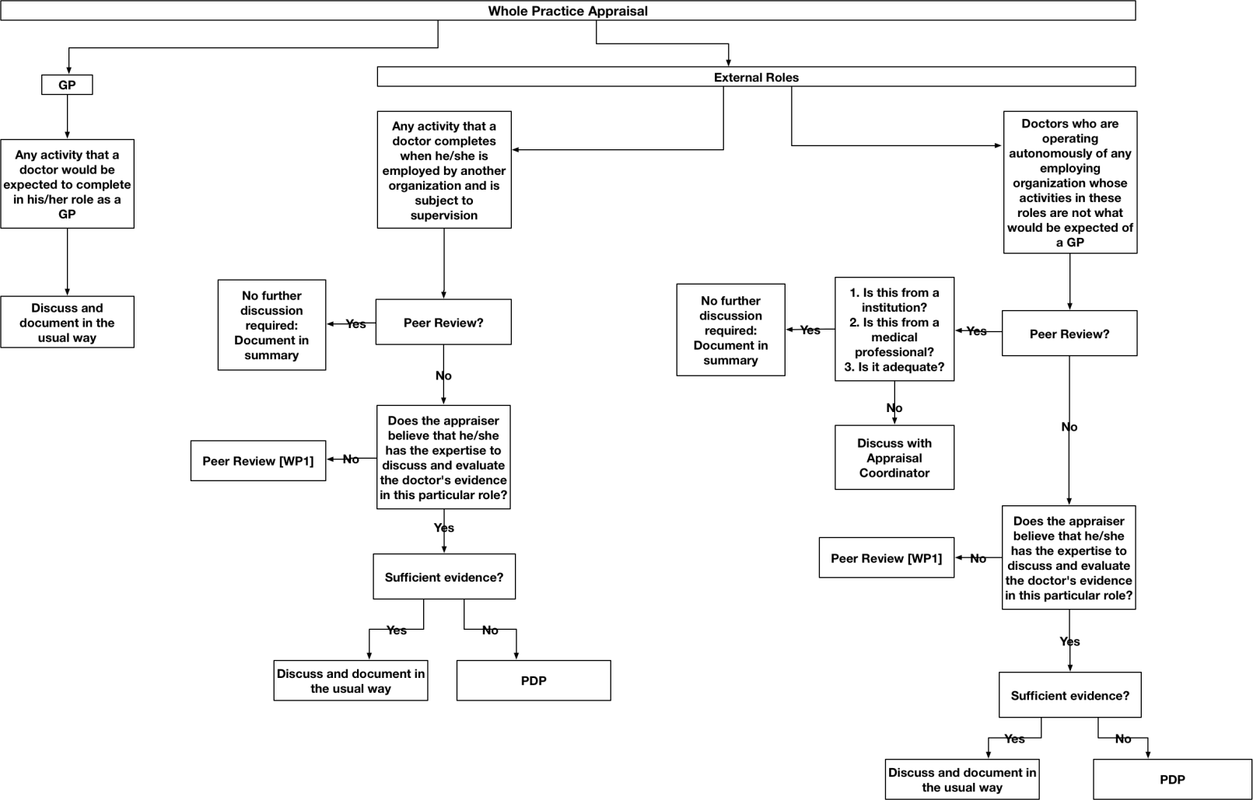

3

Whole Practice Appraisal: Guidance Notes

Introduction

With the advent of revalidation the General Medical Council [GMC] requires a doctor to present supporting information covering all aspects of their professional duties in their lead appraisal.

GP appraisal is a formative, systematic and regular review of past achievements with constructive planning of future progress. It is a continual process and part of a learning culture. GP participation in appraisal should therefore be a positive and supportive process.

GP appraisal cannot and should not take the place of clinical governance. It does not for instance involve identifying poor performance. These aspects of clinical governance have different purposes from developmental appraisal and will be dealt with by the Health Boards through separate processes.

As GP Appraisers in Wales have considerable experience and expertise in the process of appraisal, they are in a position to appraise GPs in the majority of their external roles.

The doctor’s roles with respect to Whole Practice Appraisal may be
considered as follows:

- Any activity that a doctor would be expected to complete in his/her role as a GP:

Discuss and document in the usual way.

- Any activity that a doctor completes when he/she is employed by another organization and is subject to supervision:

  - If the doctor HAS had a peer review in this particular role:

No further discussion required. A brief entry should be made in the doctor’s
summary indicating that he/she has had a peer review in this role.

  - If the doctor has NOT had a peer review in this particular role:

    - If the Appraiser believes that he/she has the expertise to discuss and evaluate the doctor's evidence in this particular role:

Discuss and document in the usual way.

The Appraiser should discuss with the doctor the supporting information that he/she would be expected to present for this role. The process can be informed by the following questions:

      - How did you qualify to take on this role?

      - How do you keep up to date in this role?

      - How do you demonstrate the quality of your practice?

      - How do you deal with significant events?

      - How do you obtain feedback?

Entries can be made in the doctor’s PDP with respect to the above discussion in order to facilitate the doctor’s educational development in this role. If in the subsequent appraisal meeting it is noted that the doctor has not completed these PDP objectives, a WP1 letter should be issued to this effect.

It is recognized that a peer review in another role is an educationally valuable exercise in it’s own right and as such should be actively encouraged. It would therefore be useful to discuss this issue with the doctor during the appraisal meeting, even if the appraiser believes that he/she is in a position to discuss and evaluate the doctor’s evidence in this particular role. An entry to this effect could be included in the doctor’s PDP emphasizing the educational benefits of this exercise.

    - If the Appraiser doesn't believe that he/she has the expertise to discuss and evaluate the doctor's evidence in this particular role or if the role, in the Appraiser’s opinion, is a substantial role:

The doctor requires a peer review in this role [WP1 letter – Appendix 1].

There is no need for the doctor to be formally appraised in order to obtain such evidence. It may be the case in some instances that the employing organisation will take the view that the doctor requires a formal appraisal/performance review in such a role, and this can be fed into the lead appraisal in the usual way.

In such cases the WPA process can be activated with the WP1 letter being issued encouraging the doctor, if necessary, to contact their RO for advice. The WP2 letter can be used, if necessary, at a later stage to specifically ask the RO for advice in terms of what the doctor should present as evidence for the purpose of Whole Practice Appraisal.

It is important to note that the WPA process is intended to be supportive of the doctor in their attempt to obtain the necessary evidence for Whole Practice Appraisal from the relevant bodies.

- Other [This category includes those doctors who are operating autonomously of any employing organization whose activities in these roles are not what would be expected of a GP]:

These doctors should be managed on a case-by-case basis. The appraisers should discuss any concerns that they may have with their Appraisal Coordinator.

- If the doctor HAS had a peer review in this particular role:

The Appraiser should evaluate the peer review with respect to the following criteria: -

  - Is this from an institution?

  - Is this from a medical professional?

  - Do I need to seek advice from my Appraisal Coordinator as to the adequacy of this information?

If the Appraiser has no concerns regarding the above [following discussion with the Appraisal Coordinator if necessary] no further discussion is required. A brief entry should be made in the doctor’s summary indicating that he/she has had a peer review in this role.

- If the doctor has NOT had a peer review in this particular role:

- If the Appraiser believes that he/she has the expertise to discuss and evaluate the doctor's evidence in this particular role:

Discuss and document in the usual way.

The Appraiser should discuss with the doctor the supporting information that he/she would be expected to present for this role. The process can be

informed by the following questions:-

  - How did you qualify to take on this role?

  - How do you keep up to date in this role?

  - How do you demonstrate the quality of your practice?

  - How do you deal with significant events?

  - How do you obtain feedback?

Entries can be made in the doctor’s PDP with respect to the above discussion in order to facilitate the doctor’s educational development in this role. If in the subsequent appraisal meeting it is noted that the doctor has not completed these PDP objectives, a WP1 letter should be issued to this effect.

It is recognized that a peer review in another role is an educationally valuable exercise in it’s own right and as such should be actively encouraged. It would therefore be useful to discuss this issue with the doctor during the appraisal meeting, even if the Appraiser believes that he/she is in a position to discuss and evaluate the doctor’s evidence in this particular role. An entry to this effect could be included in the doctor’s PDP emphasizing the educational benefits of this exercise.

- If the Appraiser doesn't believe that he/she has the expertise to discuss and evaluate the doctor's evidence in this particular role or if the role, in the Appraiser’s opinion, is a substantial role:

The doctor requires a peer review in this role [WP1 letter – Appendix 1].

In such cases the WPA process can be activated with the WP1 letter being issued encouraging the doctor, if necessary, to contact their RO for advice. The WP2 letter can be used, if necessary, at a later stage to specifically ask the RO for advice in terms of what the doctor should present as evidence for the purpose of Whole Practice Appraisal.

It is important to note that the WPA process is intended to be supportive of the doctor in their attempt to obtain the necessary evidence for Whole Practice Appraisal from the relevant bodies.

Appendix 1

WP1: Letter from Appraiser to Doctor

(Date)

Addressee Only

Re: Non-Inclusion of peer review for role/s outside of GP

Dear (insert doctor name)

During your appraisal on (insert date) we discussed your role/s as (insert role).

- This role/s is outside the scope of GP and as your GP Appraiser I would not be able to validate information provided about this role/s in a meaningful way.

- This role/s is a substantial role.

- Insufficient evidence for this role/s [The doctor’s PDP objectives, agreed during their previous appraisal meeting, relating to this role/s have not been completed].

I have documented in this year’s appraisal summary that a peer review will be required to be included for next year. As we discussed it is essential that you include this as supporting documentation in your appraisal next year (insert year) if you continue within the role/s. If you are unable to undertake an appraisal within that role/s you must contact your nominated Responsible Officer (RO) (insert contact) for advice as to their requirements for adequate coverage of the role/s. At your next appraisal the Appraiser will check if a performance review has been undertaken.

Yours sincerely

(insert Appraiser name)
Cc Appraisal Coordinator
Appraisal Officer ( heiw.appraisalofficer@wales.nhs.uk )

An example of a template that can be used to this effect is as follows:

Template for Review in Other Roles To Whom It May Concern
I am aware of the role that Dr. (insert name) performs as (insert role) at (insert place of work or organisation). This role is not subject to annual appraisal, simply review of performance. In my capacity as (supervisor/peer/specialist in this area), I confirm that Dr. (insert name) is suitably trained and maintains his/her skills and knowledge commensurate to the role. He/she performs to a satisfactory level and there are no unaddressed concerns about their practice.

Name Signature Date

This process is intended to be supportive of doctors in their attempt to obtain the necessary evidence for Whole Practice Appraisal from the relevant bodies

Yours sincerely

Appraiser

Cc Appraisal Coordinator
Appraisal Officer ( heiw.appraisalofficer@wales.nhs.uk )

Appendix 2

Frequently Asked Questions

Question | Answer
Do doctors need to include the supporting information for each role over the revalidation cycle? | No. The GMC requires that the doctor’s whole practice has been appraised, but not necessarily that each item of supporting information has been provided, for every role/s. How much evidence needs to be provided for different role/s requires a consideration of proportionality and how much supervision is provided in the other role/s. Some of the suggested questions in the guidance above may be addressed prior to the appraisal through review of the appraisal materials, so that there would be no need to discuss these during the appraisal meeting.
Are we going to advertise Appraisers with different specialties so that appraisees can be  ‘matched’ with Appraisers with comparative roles? | No. Some information can be provided in the biopic BUT appraisal must remain generic.
What is the definition of  ‘institution’? | Any Designated Body is identifiable as an institution. Beyond Designated Bodies the definition can be applied flexibly. If you are unsure discuss with your Appraisal Coordinator.
What are we being asked to confirm? | Whether there is evidence of reasonable educational activity in relation to different role/s – either via a separate peer review or included within the appraisal. This should be clearly documented in the summary.
Do Out-Of-Hours, GP training, medical politics, ‘good samaritan’ acts at local events all fall within the GP-related role? | Yes. A common sense approach should be applied.
If a WP1 letter is sent, do the actions have to be completed (i.e. peer review  received) before the | No – The WP1 letter relates to the coming year and the next appraisal.

Question | Answer
appraisal can be signed off?
Are there any roles that Appraisers shouldn’t appraise? | Proportionality needs to be considered – if there is a very substantial role you would expect to see a peer review. You will also need to consider whether the skills being used are completely different from GP skills.
What about roles, which require GMC registration but not a license to practice e.g. tribunal doctors? | Doctors without a license don’t have to revalidate.
What about GPs with no or minimal general practice? | Are they on a Medical Performers’ List [MPL]? Is there sufficient GP material on which to base a meaningful discussion? If not, refer to the Appraisal Coordinator for discussion with the Medical Director.
Is there a minimum amount of clinical practice required to remain on the MPL? | Some clinical practice is required during the year to remain on the MPL but this is not quantified. If you are out of practice for more than two years you will need to undertake a formal returner scheme.
What about the doctor doing eight sessions in hospital and one session in GP who wants their GP appraisal to be the lead appraisal? | This is fine if the Responsible Officer is happy as long as the hospital role is covered, as per the guidance, by a separate peer review as it is a substantial role. Conversely if the hospital appraisal is to be the lead appraisal it is important that the GP role is addressed in that appraisal.

